BUILDING A CHATBOT

**JORDAN: MY PERSONAL HOUSE AI**

REPORT BY : AAFREEN, BODDAPU DEEPAMAHI, MASHA SAKEER

horizontal line

# 

# 

# Introduction

A **chatbot** is an artificial intelligence that simulates a conversation with a user through apps or messaging. Chatbots are the future of AI, as they provide the closest to a natural conversation between humans and machines. Chatbots are not new to us; the first chatbot was Eliza, but it was not as complex as the chatbots we have nowadays, such as Siri or Alexa.

Due to the new ML and AI techniques, chatbots are expected to complete 90% of our tasks in the future, but there is still a long way to go. The progress we have made with chatbots thus far is, nonetheless, astonishing

## Methodology

## We have to consider a few rules with which we will base the design of our chatbot.

**Type**

Before we start implementing a chatbot, it is important to decide what type of chatbot we want to implement: rule-based, self-learning, or a mixture of the two

Self-learning chatbots: Self-learning chatbots use ML and AI techniques and algorithms to save the inputs from the user and use them later.

Rule-based chatbots: Rule-based chatbots have predefined rules that they follow.

### Target audience

### We must know the target audience for which we are making our chatbot. We cannot have a universal chatbot that can answer all questions related to a variety of possible problems.

### Natural language

We should also keep in mind the natural language of communication for the chatbot. We will choose the natural language after we have decided on the target audience.

### Responses

We also need to provide appropriate responses for initial questions to the chatbot.

# Working

The code for the chatbot is fairly simple and can be found here. Let’s outline the steps in creating a functional chatbot:

1. **Create a chatbot:** This is done using the create_bot function . The function takes the name of the bot as an input argument. This function returns an object, called bot, which is further used in the program. You may set the name of your choice. In our case, we have set it to Jordan.
2. **Train the chatbot:** This is done using the train_all_data function. The data we are training the chatbot for is shown [here](https://github.com/gunthercox/chatterbot-corpus/tree/master/chatterbot_corpus/data/english). The input argument of this function is the bot.
3. **Train with custom data:** We train the chatbot with custom data using the custom_train function .
   * The first input argument of this function is the bot itself.
   * The second argument is the custom data we want to train. This custom data takes the form of a Python list. The first element of the list is the question and the second element is its answer . You may train the chatbot with as much specific custom data as you want.
4. **Start the chatbot:** Start the chatbot using the start_chatbot function . The input argument of this function is the bot we want to start.

# Features

* We have used a Python **library**, chatterbot, to implement a chatbot.
* This library generates automated responses to the user input. The responses are based on machine learning algorithms implemented in the library.
* The ML algorithms make it easier for the chatbot to improve and evolve its responses over time as it collects user responses.

**Problem Statement**

We (**Aafreen, Deepa, Masha)** have just bought **Jordan**, the smartest AI in the world, for my house. Now we have to set it up for use.

**Solution**

Trained Jordan with all of the world’s information and then trained it with your personal information for restricted access.

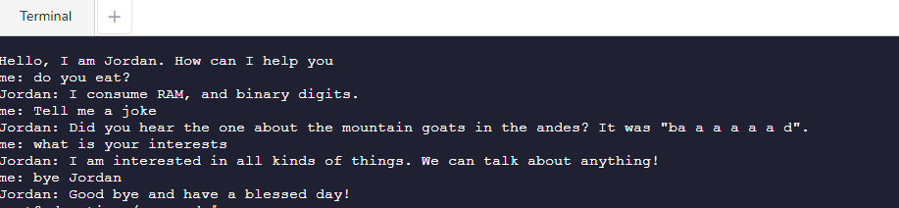

To prevent unauthenticated access to my house, only three people are allowed to access Jordan: me (**Aafreen**) and my **team mates Deepa and Masha.**

To protect my personal information, only I will have access to my personal information.

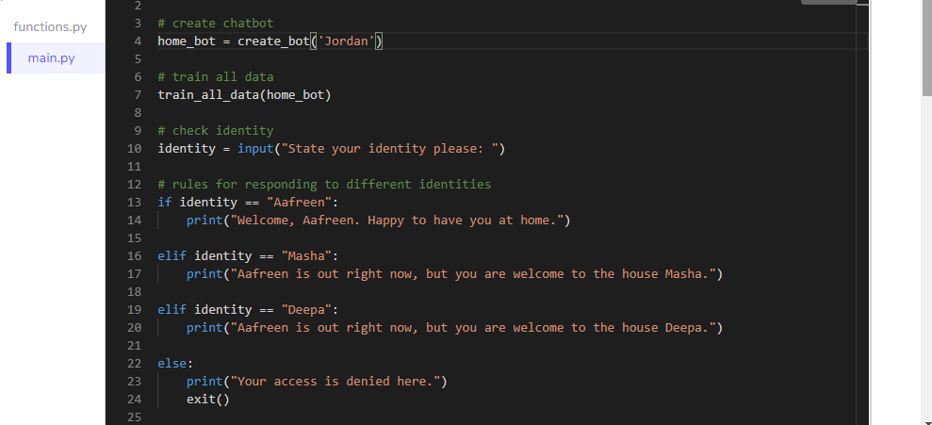

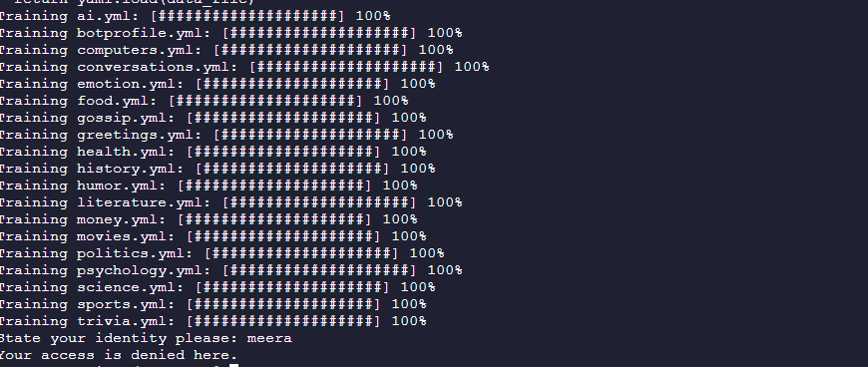

# Once the bot has identified me, I trained the bot with some personal information about me

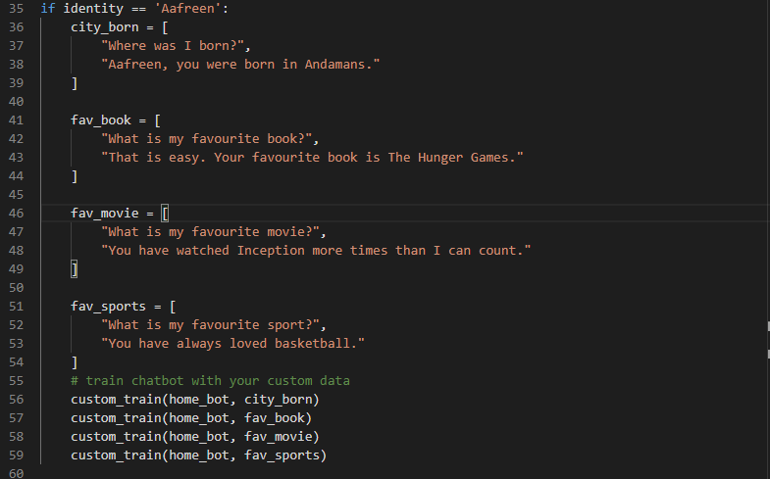

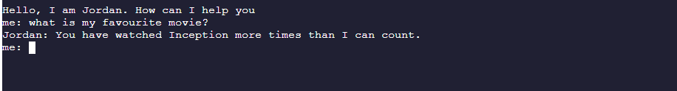

# 

# Limitations

Sometimes it can become difficult to work with the chatbot, and we have to set our expectations accordingly.

## Domain knowledge

## A chatbot is a machine, and it has specific domain knowledge. We cannot expect the chatbot to know everything about everything. We are far from the AI we see in movies, so we need to have realistic expectations while designing a chatbot.

## Conversation boundaries

While conversing with a chatbot, you will initially get a lot of wrong answers since the chatbot is unable to comprehend your statements. This may get frustrating at times, but we need to understand that we are conversing with a machine, not a human being.

## Personality

## A conversation with a computer is very different from a conversation with another human. We may expect the chatbot to have the following distinguishable human traits:

* Empathy
* Emotions
* Intelligence

We are far away from reaching a level of communication with AI that is indistinguishable from human communication, but we may achieve this sometime in the future.